ABOUT US
The love for the river that was born in early childhood and the happiest memories of the time spent on the water, led us to create and build a boat that will provide maximum pleasure for everyone, whether it is fishing, swimming on the river islands and shores, or just enjoying boating and hanging out with friends.
We dedicated ourselves with all OUR heart and approched very studiously to the creation of this vessel. In order to fulfill all your requirements, we took care of every little detail. In cooperation with shipbuilding engineers, we were able to submit the Plan of stability and navigability, and started with a production of a completely new model on the market, which will satisfy the needs of even the most demanding clients.
After a little more than a year since the first sketch was made, we are pleased to present our first model BODO 540, and our story does not finish there... it has only started.
BODO 540
What distinguishes the BODO 540 is its modern design, exceptional navigability, precision in manufacturing and, above all, user safety. Quite a number of boxes (five), which can be modified according to your wishes and needs, will allow you to organize the necessary accessories and equipment for a maximum comfortable time spent on the water.
The depth of the boat (0.65 m) without fences, will provide the necessary sense of security for you and your companions, and the length of the boat (5.65 m) will certainly contribute to your safety on windy days, when there are waves on the water. It is also important to add that this boat has 12 separate air chambers, which makes it almoust unsinkable.
All the mentioned characteristics are also confirmed by official Examination Report of the German certification company DNV. BODO 540 was certfied with CE Certificate of compliance with European standards.
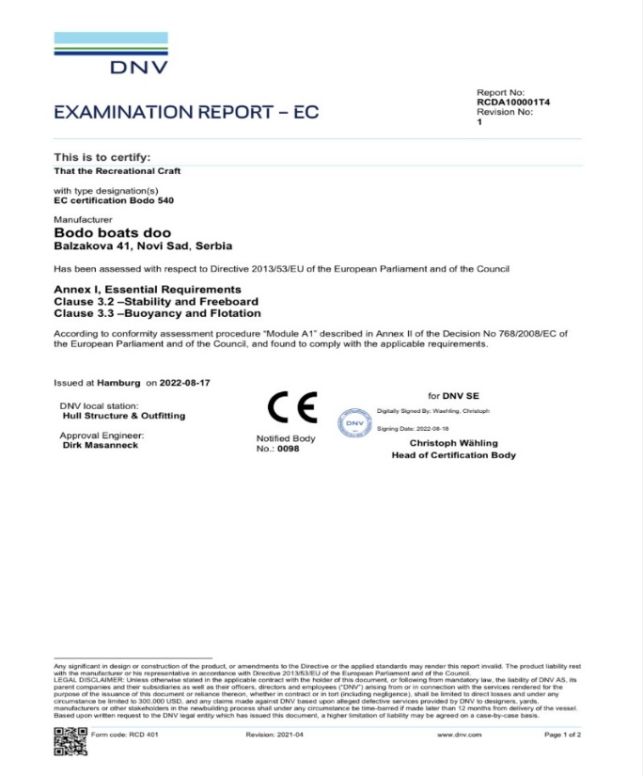

DIMENZIJE I TEHNIČKA DOKUMENTACIJA
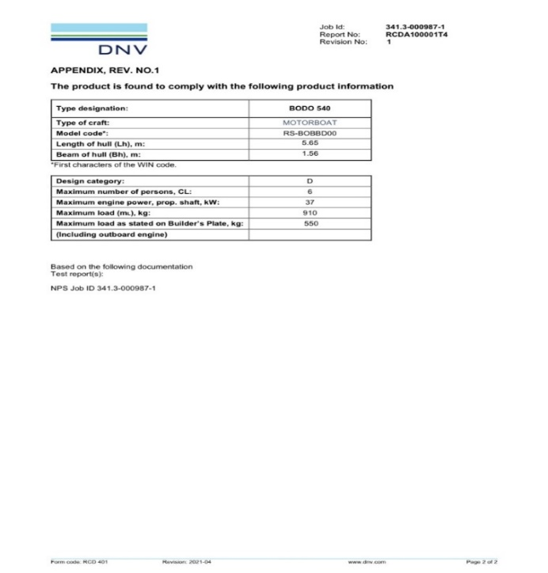
DIMENSIONS AND TECHNICAL DOCUMENTATION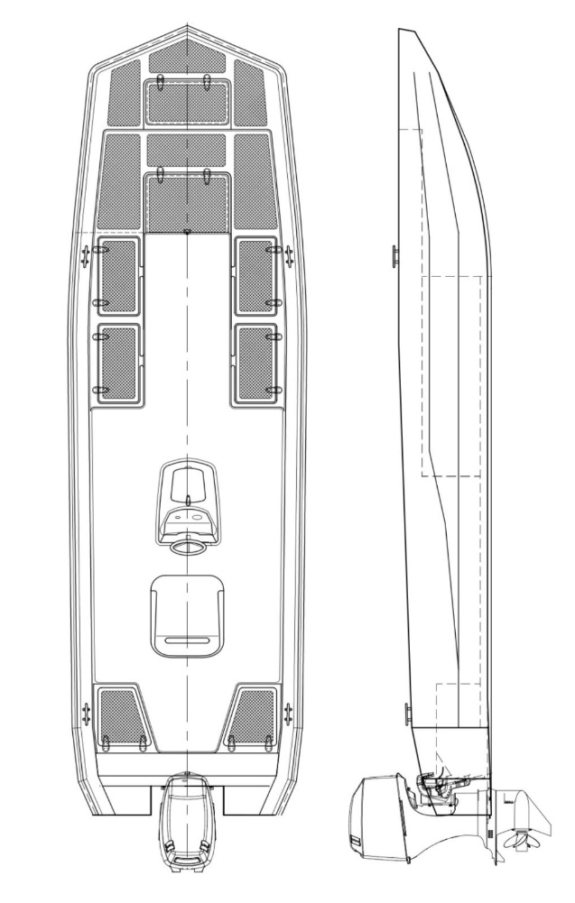
LENGTH: 5.65 m
WIDTH: 1.56 m
DEPTH: 0.65 m
WEIGHT: 230 kg
MAX ENGINE POWER: 50hp (37kw)
MAX LOAD: 550kg
NUMBER OF PASSENGERS: 6 persons

